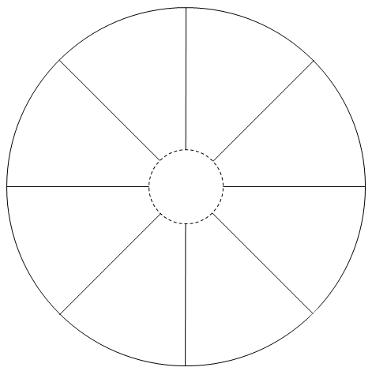

**http://hobby-mk.ru**

**http://hobby-mk.ru**